**Automatic Fire Extinguisher:**

**Extinguish the flames with Arduino Uno.**

**Introduction:**

Fires can be devastating, and having a reliable fire extinguisher can make all the difference. But what if you could take it a step further? What if you could build your own fire extinguisher using Arduino Uno? In this presentation, we will explore the benefits of using Arduino Uno for fire extinguishers and guide you through the process of building your own device.

Imagine being able to customize your fire extinguisher to fit your specific needs. With Arduino Uno, you can do just that. Whether you want to add extra sensors or adjust the spray pattern, the possibilities are endless. So, let us dive in and see how you can take fire safety into your own hands.

**Why use Arduino Uno?**

Arduino Uno is a microcontroller board that allows you to program and control various electronics devices. It is affordable, easy to use, and has a large community of developers and enthusiasts, But why use Arduino Uno for fire extinguisher?

Firstly, Arduino Uno allows you to add multiple sensors to your fire extinguisher, such as temperature and smoke detectors This means that your device can detect lives earlier and respond more effectively, Additionally, Arduino Uno enables you to adjust the spray pattern and intensity of your tire extinguisher, making it more efficient and reducing waste Finally, by using Arduino Uno, you have complete control over your device and can customize it to the your specific needs.

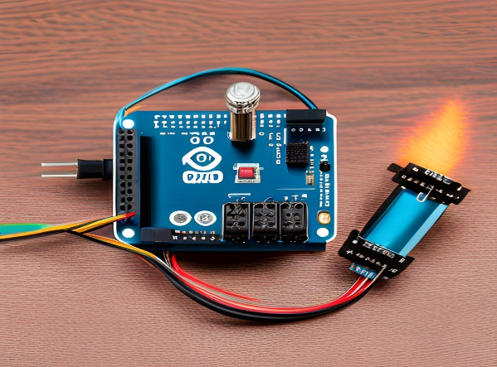

**Components required:**

To build a fire extinguisher using Arduino Uno, you will need several components. Firstly, you will need an Arduino Uno board and a power source, such as a battery or USB cable. You will also need a relay module to control the spray pattern of your device. You will need a buzzer, which creates an audible alarm or notification system.

In addition, you will need sensors to detect fires, such as temperature and smoke detectors. You will also need a mini water pump source, which can create a small water circulation system for automating water-related tasks. Finally, you will need a container to hold the extinguishing agent, such as water or foam, and a nozzle to spray it out. With these components, you can start building your own fire extinguisher using Arduino Uno.

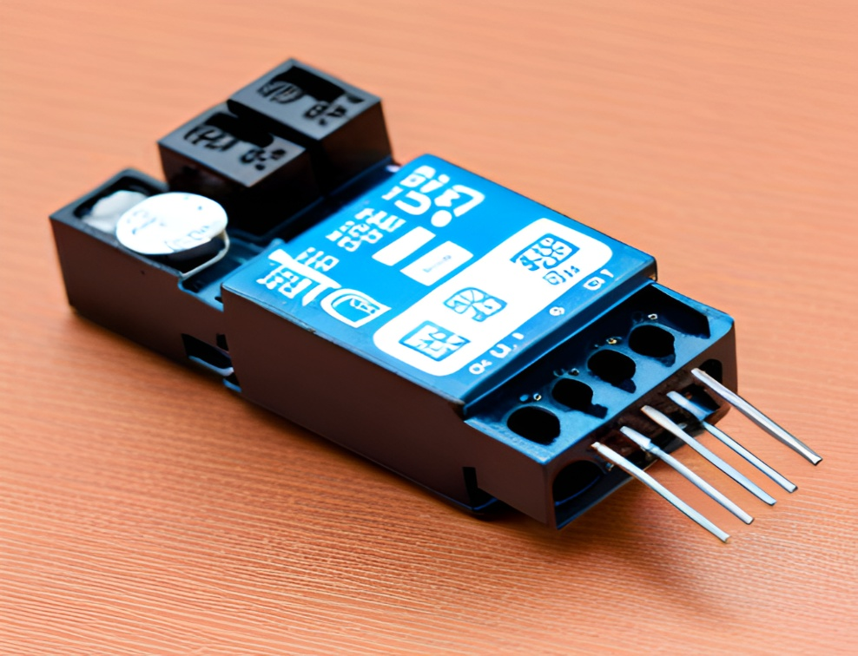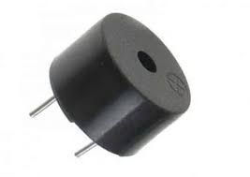

**Code Design:**

int flame=0;// select analog pin 0 for the sensor

int Beep=9;// select digital pin 9 for the buzzer

int val=0;// initialize variable

int relay= 13;

/* The setup () function is called when a sketch starts. It is used to initialize variables, pin modes, start using libraries, etc. This function will only run once, after each power up or reset of the Arduino board. */

void setup()

{

pinMode(Beep,OUTPUT);// set buzzer pin as “output”

pinMode(relay,OUTPUT);// set LED pin as “output”

pinMode(flame,INPUT);// set flame pin as “input”

Serial.begin(9600);// set baud rate at “9600”

}

/* The loop() function executes the program repeatedly until Specified. */

void loop()

{

val=analogRead(flame);// read the analog value of the sensor

Serial.println(val);// output and display the analog value

if(val>=500)// when the analog value is larger than 600, the buzzer will buzz

{

digitalWrite(Beep,HIGH);

digitalWrite(relay,HIGH);

}else

{

digitalWrite(Beep,LOW);

digitalWrite(relay,LOW);

}

delay(500);

}

**Circuit diagram:**

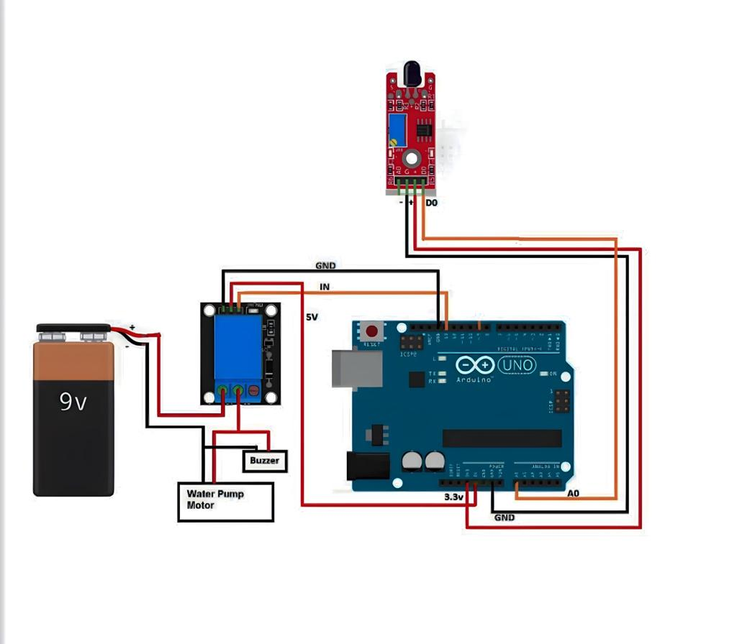

**Building the fire extinguisher:**

Building a fire extinguisher using Arduino Uno may seem daunting, but it is quite straightforward. Firstly, connect the sensors to your Arduino Uno board and program them to detect fires. Next, connect the relay module to control the spray pattern of your device.

Finally, assemble the container and nozzle for your extinguishing agent and connect them to the relay module. Once everything is connected, test your device to ensure it is working correctly. With a little bit of patience and some basic electronics knowledge, you can have your very own custom fire extinguisher using Arduino Uno.

**Testing the fire extinguisher:**

Once you have built your fire extinguisher using Arduino Uno, it is important to test it to ensure it is working correctly. Firstly, test the sensors by exposing them to heat or smoke and verifying that they trigger the device.

Next, test the spray pattern and intensity of your extinguishing agent to ensure it is effective.

Finally, test the overall functionality of your device by simulating a fire and seeing how it responds. By testing your fire extinguisher, you can be confident in its ability to keep you and your loved ones safe in case of an emergency.

**Applications:**

The use of an Arduino and a fire extinguisher together can improve fire safety systems and offer more functionality and automation. Here are a few possible uses for an Arduino-powered fire extinguisher:

* Fire Detection and Alert: An interface between an Arduino board and a fire detection sensor, such as a smoke detector or flame sensor, is possible. When a fire is discovered, the Arduino can sound an alarm, turn on visual indications like LEDs, and send information to the user via messaging applications such as SMS or push notifications.
* Automatic Fire Extinguishing System: Using data from fire sensors, Arduino can regulate the activation of a fire extinguisher. The Arduino can automatically activate the fire extinguisher when a fire is detected, dispensing extinguishing materials like water, foam, or carbon dioxide to put out the fire. This automated method can respond more quickly and lessen the chance of human error.
* Fire Suppression in Enclosed Spaces: Arduino can be used to regulate the release of fire-fighting agents in small compartments, electrical cabinets, and server rooms. The system can monitor the temperature and activate the fire extinguisher when it rises above a predetermined threshold by merging temperature sensors and Arduino, protecting delicate equipment.
* Arduino can enable remote monitoring and fire extinguishers. The Arduino can update a central monitoring system or mobile app with real-time fire status information by integrating wireless communication modules like Wi-Fi or GSM. This enables users to get notifications, remotely monitor fire extinguishers, and, if needed, activate them.

Fire safety is a crucial topic, and any system utilizing fire extinguishers needs to adhere to all applicable safety standards and laws. When developing and putting in place fire safety measures, experienced guidance and knowledge should be looked for.

**Conclusion:**

In conclusion, building a fire extinguisher using Arduino Uno is not only a fun and rewarding project, but it also provides numerous benefits over traditional fire extinguishers. With Arduino Uno, you have complete control over your device and can customize it to fit your specific needs.

By adding sensors and adjusting the spray pattern, you can make your device more efficient and effective at putting out fires. So why not take fire safety into your own hands and build your own fire extinguisher using Arduino Uno? With a little bit of creativity and some basic electronics knowledge, you can have a device that will keep you and your loved ones safe for years to come.

**Project Developed by:**

P.Sudeep Reddy(AP22110020104)